Here we will create a simple application using docker build.

1. SSH to your AWS Workstation.

|  |
| --- |
| $ sudo su (password is Dev0p$!!/ ) |

2. Clone the **Git Repo** that contains the python code.

|  |
| --- |
| # git clone https://github.com/LovesCloud/Docker-compose-demo-PwC.git # cd Docker-compose-demo-PwC/ui/ |

**3.** Create a Dockerfile

|  |
| --- |
| # vim Dockerfile |

Pate the below code to the **Dockerfile** and save the file

|  |
| --- |
| FROM nginx:1.13.7 COPY index.html /usr/share/nginx/html COPY . /usr/share/nginx/html RUN echo "Copying index.html to Container"  RUN echo "Preparing the new container" |

|  |
| --- |
| # docker build . -t dockerfiledemo |

4. Verify that the image has been build

|  |
| --- |
| # docker images |



5. Run an Image from the Image created

|  |
| --- |
| # docker run -d -p 80:80 --name dockerfiledemo dockerfiledemo |

6. Check the docker container details.

|  |
| --- |
| $ docker ps |

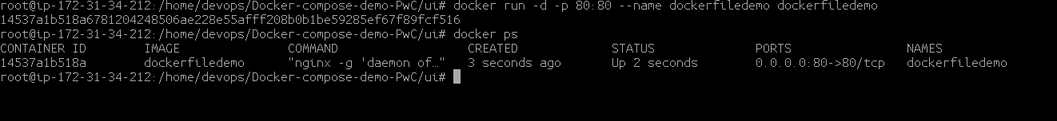

7. Goto the browser and browse the host on default port 80 to test.

**http://<public-ip-of-your-workstation>**

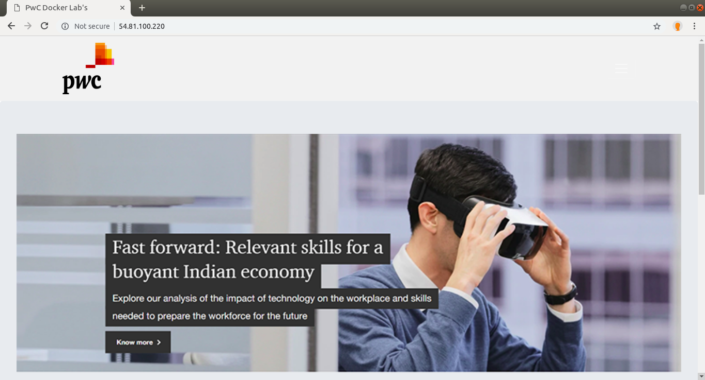8. STOP the containers before proceeding to the next lab

|  |
| --- |
| $ docker stop dockerfiledemo |